**DAILY ONLINE ACTIVITIES SUMMARY**

|  |  |  |  |  |  |  |  |  |
| --- | --- | --- | --- | --- | --- | --- | --- | --- |
| **Date:** | **4-06-2020** | | | | | **Name:** | **Rakesh M Kotian** | |
| **Sem & Sec** | **8 th sec-b** | | | | | **USN:** | **4al16cs072** | |
| **Online Test Summary** | | | | | | | | |
| **Subject** | | **-** | | | | | | |
| **Max. Marks** | | **-** | | **Score** | | |  | |
| **Certification Course Summary** | | | | | | | | |
| **Course** | **Python for machine learning** | | | | | | | |
| **Certificate Provider** | | | **Great learning** | | **Duration** | | | **6 hours** |
| **Coding Challenges** | | | | | | | | |
| **Problem Statement:** | | | | | | | | |
| **Status:solved** | | | | | | | | |
| **Uploaded the report in Github** | | | | | **yes** | | | |
| **If yes Repository name** | | | | | **Rakeshkotian08** | | | |
| **Uploaded the report in slack** | | | | | **yes** | | | |

Online Test Details: (Attach the snapshot and briefly write the report for the same)

Certification Course Details: (Attach the snapshot and briefly write the report for the same)

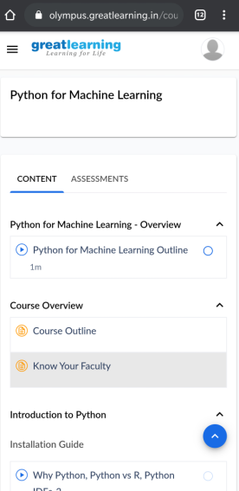

|  |  |
| --- | --- |
| t = int(input())  for i in range(t):      m, c = input().split()      a = [int(j) for j in input().split()]      print(a)      s = sum(a)      if int(s) < int(c) or int(s) == int(c) :          print("Yes")      else:          print("No")   |  | | --- | |  | |